Step 1:

Add library file: Sketch>Include Library>Add.ZIP Library

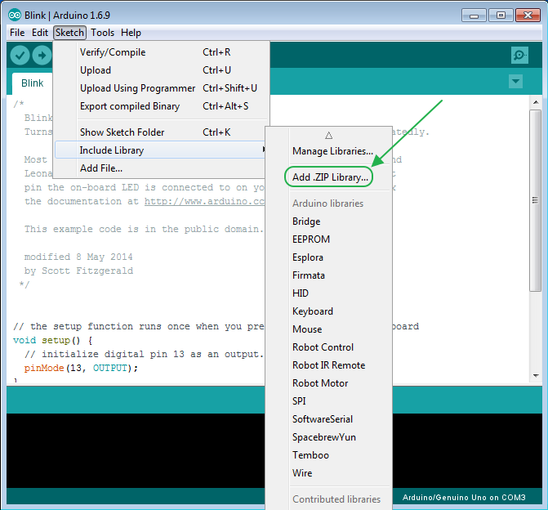

Step 2:

Select your library file compression package, as follows

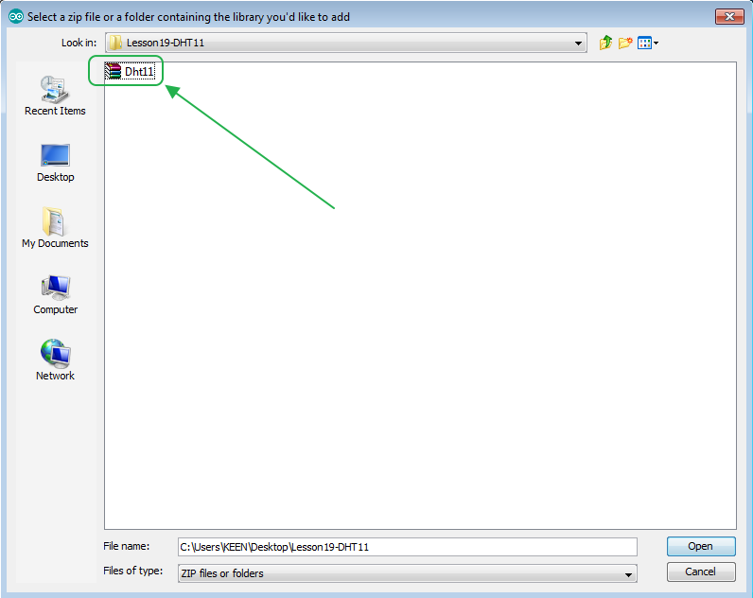

Step 3: Finish.